Day 14 : 8 Nov 2024 CB FSD - Planning and UI Design

Looping :

Looping is use to execute the code line by line till the condition become false.

Initialization: start and end

Condition it can be true or false.

Do the task

Increment and decrement the value.

While loop

Do while loop

For loop

1 2 4

for(initialization;condition;increment/decrement) {

body the loop 3

}

Initialization only once.

User defined functions.

In JavaScript we can create user defined function lot of ways.

Simple function syntax

function functionName(parameterList){

function body;

}

1. Function no passing parameter as well as no return type.
2. Function with passing parameter but no return type.
3. Function with passing parameter as well as return value.

Events : event provide the bridge between html code and JS code. Whenever user interact with any html tag different type of event generate.

Like click on button, mouse over, mouse out, key press(typing), web page opening.

JavaScript provided lot of different types of event and all those event start with pre-fix on followed by event name.

Like

onClick

onDblClick

onMouseOver

onKeyUp

onKeyDown

onSubmit

onChange

onload

onUnload etc

<input type=”button” value=”Click Here” onClick=”fun1()”/>

<input type=”text” name=”fname” onKeyUp=”fun2()”/>

<img src=”name.jpg” onMouseOver=”fun3()”/>

OOPs : Object Oriented Programming

object : object is any real world entity.

Every object hold two things

1. Property or state
2. Behaviour

Property or state 🡪 have🡪name, age, height, etc

Using variable we can provide property details.

Person

Behaviour -🡪do/does 🡪 teaching(), sleeping(),talking() etc

Using function we can write the behaviour of that object.

Bank

Car

Animal

Customer

Employee

class : class is blue print of object or template of object or user defined data type which help to describe the object or class collection of object which have same property and behaviour etc.

In JavaScript object are divided into 2 types.

1. Pre defined objects or built in objects.

Java script provided two main hierarchy for pre defined object.

BOM Hierarchy : Browser Object Model

DOM Hierarchy : document object model

Object -🡪 Property (variables)

Behaviour (functions)

Object -🡪

Property

Behaviour

Object -🡪

Property

Behaviour etc

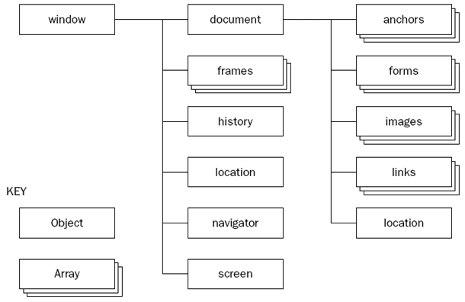

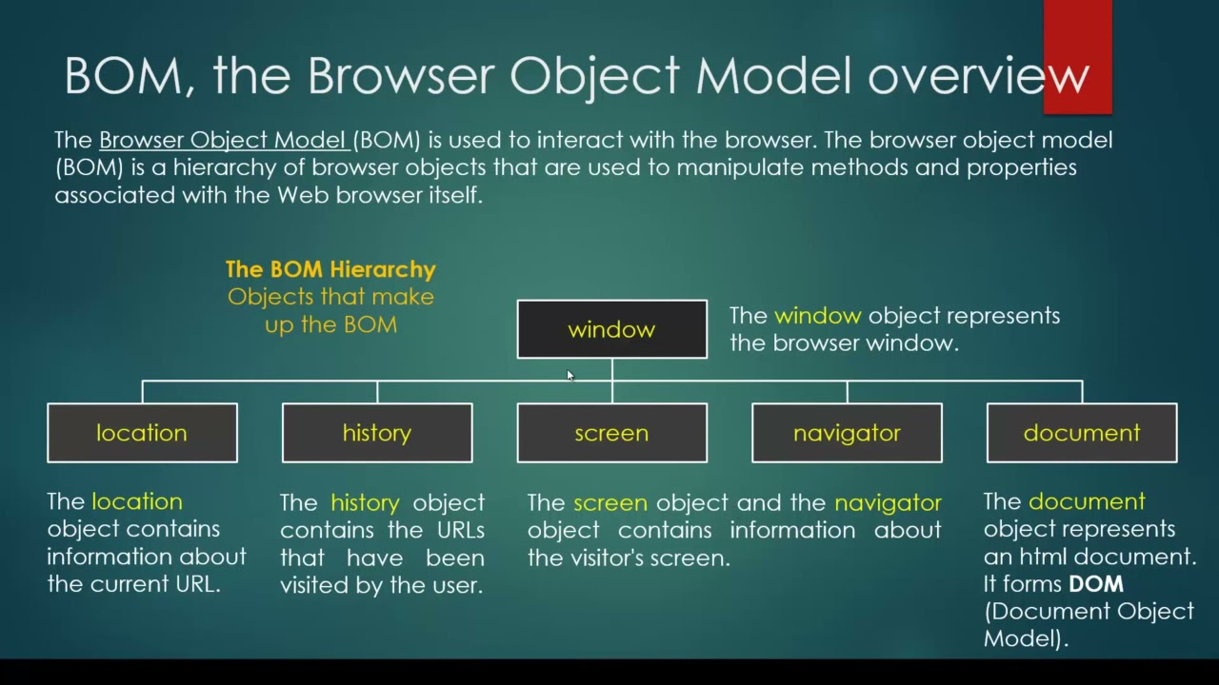

In BOM window is top most object. Location, history, screen and navigator as well ad document are property for window object.

Document is top most object in DOM hierarchy.

To access property and behaviour of user defined or pre defined object we need to follow below

objectName.propertyName;

it is use to access that property value

objectName.propertyName=value;

we can assign the value for that property

objectName.functionName();

it is use to call function part of that objects to do some task.

document.write(“Welcome to JS”);

1. User defined objects.

For in loop

For of loop

forEach functions